- Develop a Java program to create a class Student with members USN and name. Include methods to accept and display student details. Create multiple student objects and display their information.
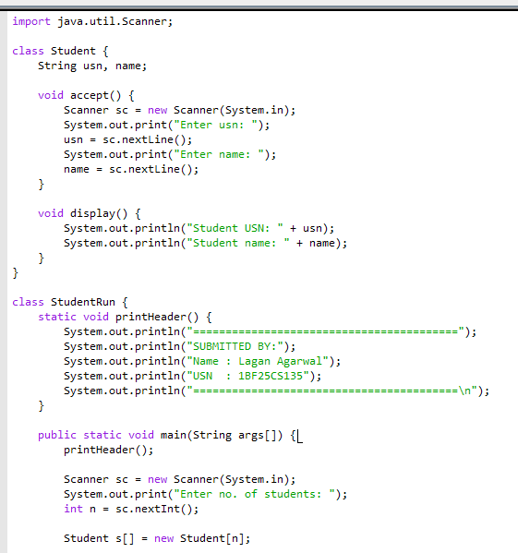
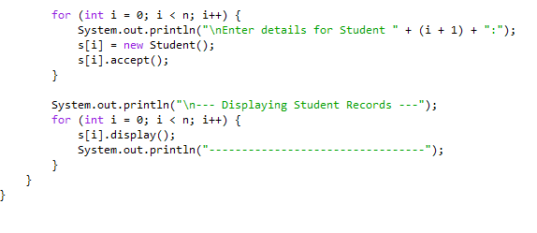
OUTPUT : 

